Test Runner – Mbunit Framework (Gallio Icarus)

**This document deals with**

1. Download and add references to visual studio to run Test Using Gallio Icarus test runner
2. How to run test using Gallio Icarus.

**Tools required**

1. VS2010 or higher

2. Gallio v3.4.11 and Mbunit 3.4.0

**Steps to add references**

1.Download the latest Version of Gallio Icarus Test Runner(Zip File)

**Url To Download Gallio -** <https://code.google.com/archive/p/mb-unit/downloads>

2.Extraxt the Zip file and keep it on physical path

3.Open Visual Studio and ->References->Add References and click on add References

4.On Popup select Browse tab->Browse to the Folder (Ex- Drive/ GallioBundle-3.4.14.0/bin)

5.From Bin Folder select and Add -> **Gallio.dll** and **MbUnit.dll** references.

**Running Test Using Gallio Test Runner**

Once the references are added one can run test using Gallio test runner with simple steps as follows

**Visual Studio Side Changes**

1. Add below two using statements in every test

**Using Gallio. Framework;**

**Using MbUnit.Framework;**

2.Test Attributes needs to be added in every test i.e. [TestFixture],[SetUp],[TearDown],[Test]

(Need to Write Test Below [Test] attribute.)

3. Build the solution and fix errors if any.->It will create a dll file under bin folder of Project

(Ex- Drive/ProjectSolutionName/bin/debug/ ProjectSolutionName.dll)

**Gallio Icarus side changes –**

1.Run Gallio.Icarus.exe ( Drive:\Setups\GallioBundle-3.4.14.0\bin\Gallio.Icarus.exe) to open test runner

2.Click On Add File on Gallio Icarus as shown in below screen shot

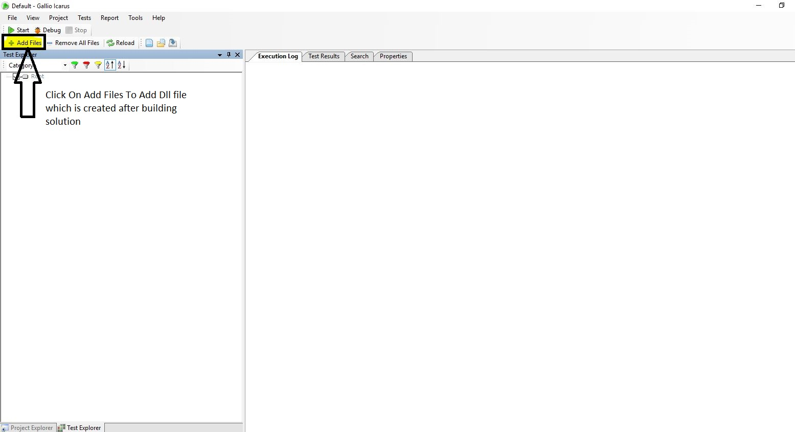

2.It will open PopUp ->navigate to the path (Ex- Drive/ProjectSolutionName/bin/debug/ ProjectSolutionName.dll) where dll is created and open that dll.

3.Which will show all the tests created in project

4.Select the test and Click on Start Button to run the test.